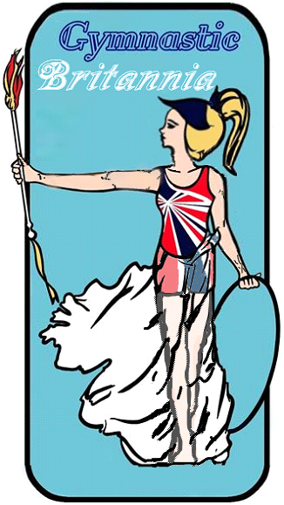
Gymnastic Britannia anti-bullying policy
Our anti-bullying policy sets out how we feel about bullying as a club or organisation, what we’ll do to tackle it and how we’ll support children and young people who experience or display bullying behaviour.

Bullying

- all forms of bullying will be acted upon
- everybody in the club or organisation has a responsibility to work together to stop bullying
- bullying can include online as well as offline behaviour
- bullying behavior can include:
  - physically pushing, kicking, hitting, pinching etc.
  - name calling, spreading rumours, persistent teasing and humiliation or the continual ignoring of others
  - posting of derogatory or abusive comments, videos or images on social media
  - racial, homophobic, transphobic or sexist comments, taunts or gestures
  - sexual comments, suggestions or behaviour
  - unwanted physical contact

Our club or organisation will:

- recognise its duty of care and responsibility to safeguard all players from harm
- promote and implement this anti-bullying policy in addition to our safeguarding policy and procedures
- ensure that bullying behaviour is not tolerated or condoned
- require all members of the club/organisation to sign up this policy
- take action to investigate and respond to any reports of bullying from children and young people
- encourage and facilitate children and young people to play an active part in developing and adopting a code of conduct for behaviour
- ensure that coaches are given access to information, guidance and training on bullying

Each participant, coach, volunteer or official will:

- encourage individuals to speak out about bullying behaviour
- respect every child’s need for, and right to, a play environment where safety, security, praise, recognition and opportunity for taking responsibility are available
- respect the feelings and views of others
- recognise that everyone is important and equal, and that our differences make each of us special and worthy of being valued
- show appreciation of others by acknowledging individual qualities, contributions and progress
- ensure safety by having rules and practices carefully explained and displayed for all to see
- report incidents of bullying behavior they see – by doing nothing you are condoning the behaviour

Supporting children

- we’ll let children know who will listen to and support them
- we’ll create an “open door” ethos where children feel confident to talk to an adult about bullying behaviour or any other issue that affects them
- potential barriers to talking (including those associated with a child’s disability or impairment) will be acknowledged and addressed at the outset to enable children to speak out
- we’ll make sure children are aware of helpline numbers
- anyone who reports an incident of bullying will be listened to carefully and reports will be taken seriously
- any reported experience of bullying behavior will be investigated and will involve listening carefully to all those involved
- children experiencing bullying behavior will be supported and helped to uphold their right to play and live in a safe environment
- those who display bullying behaviour will be supported and encouraged to develop better relationships
- we’ll make sure that sanctions are proportionate and fair

Support to the parents/guardians

- parents or guardians will be advised on the club or organisation’s bullying policy and practice
- any experience of bullying behaviour will be discussed with the child’s parents or guardians
- parents will be consulted on action to be taken (for both victim and bully) and we’ll agree on these actions together
- information and advice on coping with bullying will be made available
- support will be offered to parents, including information from other agencies or support lines

Useful contacts

NSPCC Helpline 0808 800 5000
Childline 0800 1111 / www.childline.org.uk Kidscape www.kidscape.org.uk
Anti-Bullying Alliance www.antibullyingalliance.org

