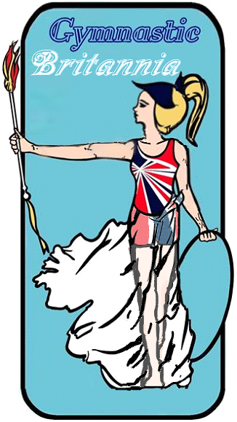
Ratio Guidance: - Effective Aug 2021
- All Sessions must be run by qualified coaches, if necessary, with suitably experience and or qualified officials / Junior Coaches.
- All sessions should be run in accordance with safe Participant Ratio:

All Disciplines:
• Additional Needs Varies Between 1:1 and 1:8 subject to
adequate risk assessments

Trampoline:
• As per Pre-school and Recreational Guidelines
• Max of 8 Per trampoline
• Ratios should be designed via a risk assessment to ensure safety
and viewability.

Pre-School:
• Pre-school participants Independent Ratio 1:8 this is subject to experience and
qualifications
• Adult & Toddler Free-Play Sessions Ratio 1:20 Adults must stay and actively supervise
and manage their children

Recreational Sessions Older Participants:
• 4yrs+ recreational Sessions Ratio 1:16 subject to experience and qualifications

Adult Sessions:
• Adult Sessions Ratio 1:16 Subject to experience and qualifications.

All Disciplines Additional Supervisors:

All the above are guidelines and should be backed up with suitable risk assessments specific to required session structure, in addition per qualified helper who has either a proficiency Assessor / proficiency Coaching award or level 1 qualification may supervision then they may supervise within the session an additional 8 maximum going up to a maximum of 24 participants if it goes over 24 then you should have an additional level 2 coach

