{ /JI- Child Protection
NSPCC
in Sport Unit
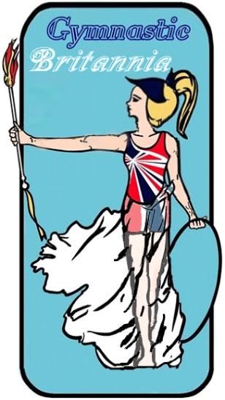
Created by the NSPCC Child Protection in Sport Unit.

Code of conduct for children and young people

Note: Where we refer to 'parents' we mean parents and carers inclusively. The term 'children' or 'child' describes any person under the age of 18.

As a young person taking part in our club or activity, we'd like you to:

The essentials

' keep yourself safe by listening to your coach or trainer, behaving responsibly and speak out when something isn't right
' when you're with us, stay in the places where you're supposed to, don't wander off or leave
without telling a member of staff
take care of our equipment and premises as if they were your own
' make it to practices or sessions on time and if you're running late, let a member of staff know
' bring the right kit to practice and wear appropriate kit for the weather
not smoke or consume alcohol on our premises or during practices, competitions or when representing us

Behaviour

respect and celebrate difference in our club or activity and not discriminate against anyone else on the grounds of gender, race, sexual orientation or ability
report any incidents of bullying, including homophobia and transphobia to a member of staff, even if you're just a witness
' treat other young people with respect and appreciate that everyone has different levels of
skill and talent
make our club or activity a welcoming and friendly place to be
support and encourage your team mates. Tell them when they've done well and be there for them when they're struggling
' respect our staff, and the staff and young players from other teams
' be a good sport, celebrate when we win and be gracious when we lose play by the rules and have fun
follow our online safety and internet use policies
' get involved in club or activity decisions, it's your sport too

Sample code of conduct for children Child Protection in Sport Unit
NSPCC

As a young person taking part, we understand you have the right to:

' enjoy the time you spend with us and know that you're safe
' be told who youcantalk to if something's not right
' be listened to
' be involved and contribute towards decisions within the club or activity
' be respected by us and other team members and be treated fairly
' feel welcomed, valued and not judged based on your race, gender, sexuality or ability be encouraged and develop skills with our help
be looked after if there's an accident or injury and have your parents informed if needed

We expect all young people to follow the behaviours and requests set out in this code. If any young person behaves in a way which contradicts any of the points set out above, we'll address the problem straight away with parent's involvement and aim to resolve the issue.

Continued issues and repeated breaches of this code may result in us regrettably asking you to leave the activity, event or club permanently, for the welfare of other young people and our staff. This is something we never want to do.

.········ ..··-··'•.........................", ....... -. ................", ........

."' Signature of young person:
•
; .,.. Signature of parent:
.....
••
•.,..

: Date: •
• •

